P.18

Test failed, due to the method for the priest's heal spell not having a reduce mana pool method within it.
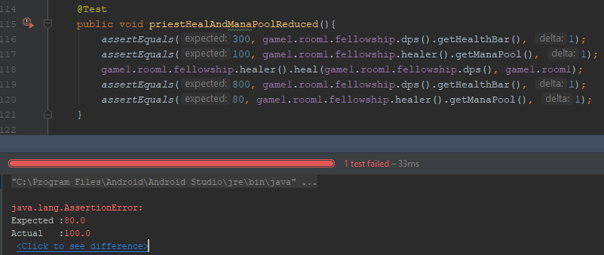
Here is the code for the method being called.
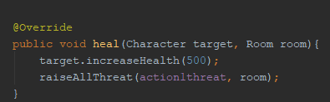
Here it is with the addition of the method to reduce the mana pool of the caster appropriately.

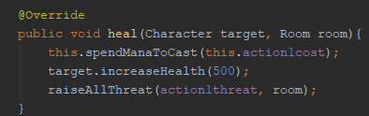
This then allows the test to pass.
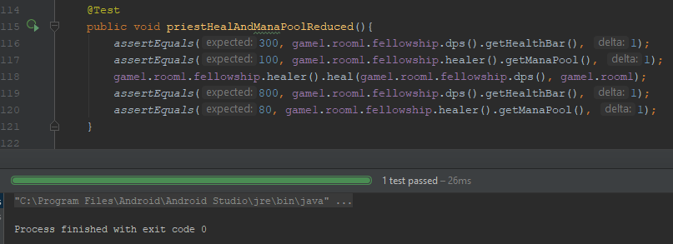

P16 The API is called from the open tech calendar website here.
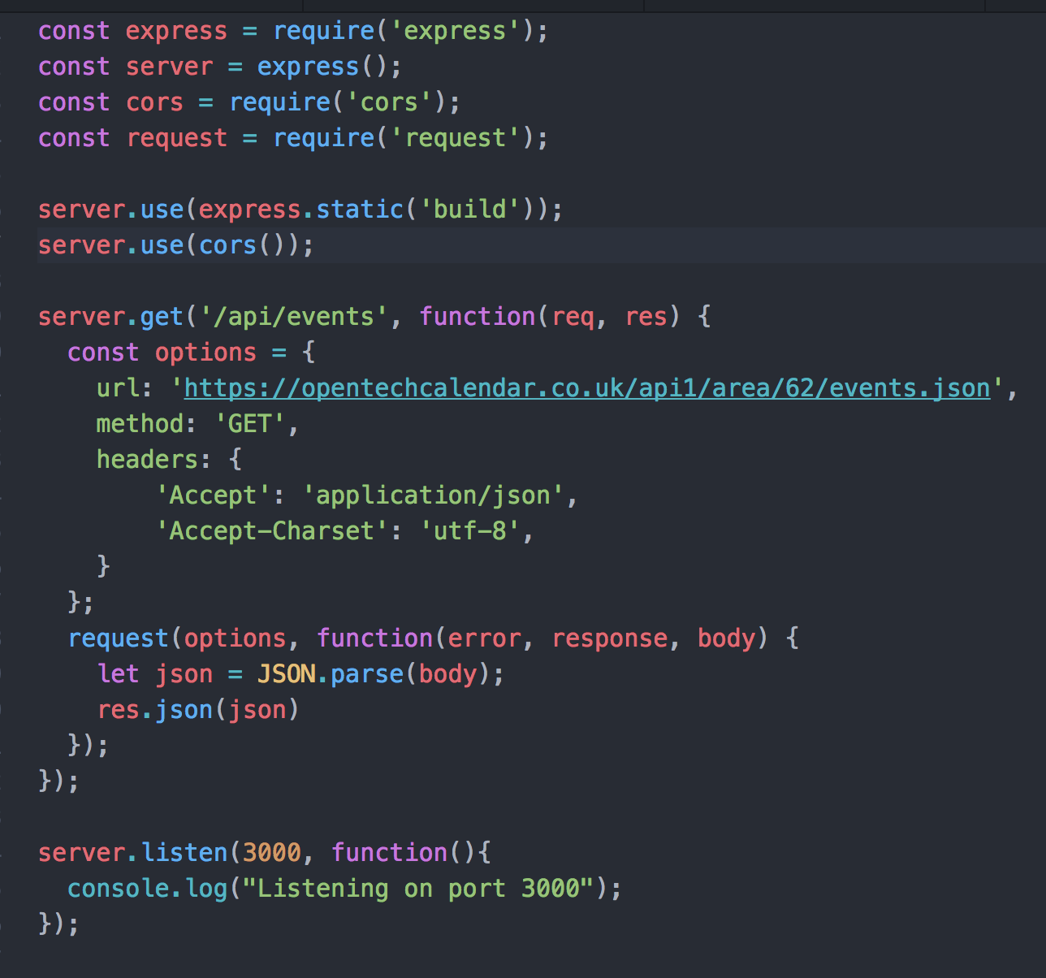
P.16 The incoming information is chopped up and displayed in a more meaningful fashion for the user.
